

Subscribe to DeepL Pro to edit this document.  
Visit [www.DeepL.com/pro](https://www.deepl.com/pro?cta=edit-document)for more information.

Year: 2022-2023

INTEGRATED PROJECT REPORT: PI1 GI

RESERVATION MANAGEMENT

A SPORTS COMPLEX

"Fitness Pal"

*Project carried out* by

Ihab Bokal

El Mehdi Boukhobza

Yasser El Omrani

Rania Oulhaj

*Project supervised* by

P. El Hadri

1. **INTRODUCTION**

As part of our first year of the engineering cycle in Computer Science and Digitalization at EMI, we are offered a 10-week project allowing us to implement our knowledge acquired in Programming, Algorithms and Data Structures, as well as in databases, with the aim of studying, designing, defining and implementing a data management application.

Our group composed of Ihab Bokal, El Mehdi Boukhobza, Yasser El Omrani and Rania Oulhaj, seized this opportunity to submit the draft of an innovative personal project to the group supervisor Professor El Hadri.

1. **PROJECT NEEDS AND OBJECTIVES**
2. **BACKGROUND**

Several acts of vandalism take place in sports grounds; the main cause is the bad management of reservations. A bad management of the reservations generates numerous problems affecting several areas, in particular: the customers, the reputation of the company in question, the turnover... Indeed, among the cases frequently met in this kind of situation, we can quote: the interference of the customers' slots, the overloading of the sports grounds or the reservations forgotten or not taken into account by the administration. All these situations frustrate the customer and make him turn to the competition. Being organized when providing a service is the least you can do, especially in a field like sports facilities that involves a lot of operational processing. The quality of customer service is paramount and can make THE difference between success and failure.

1. **MOTIVATION**

Based on this premise, we came up with the idea of overcoming this dissatisfaction among the public and providing a solution to the problem of poorly managed reservations of sports facilities, thus allowing not only the administrators of the venues to ensure that the reservations are made in a well-organized and timely manner and have a global and up-to-date view of them, but also to customers to fully enjoy the services provided without hindrance and interruption.

With these objectives in mind, we created "Fitness Pal", the "Booking made easy".

1. **SOLUTION**
2. **PROJECT**

This project being personal, our first mission was to define ourselves a forward-looking strategy as well as the objectives to reach. Of course, this strategy has evolved over time to meet our requirements, but also the constraints we faced. We have thus woven our reflection with the relationship between the user and the sports complex as a guiding thread.  
  
 First of all, ***the user*** and ***the administrator***, the pillars of our project: it is for them that our service is dedicated. It is therefore essential to identify all their needs in order to remedy them in the simplest and most efficient way.

***Fitness Pal***, the heart of our project: It plays the role of intermediary between the user and the administrator. *Fitness Pal* is a website dedicated to the reservation of sports facilities within a sports complex. After registering, the user will be able to easily access the type of field he wants to rent, choose the day and the time slot that he likes, of course within the limits of availability, and validate his choice without any hassle. The customer will of course be able to modify his registration information as he sees fit. Once this is done, the administrator of the complex will be able to access the data recorded by the user and in turn store them in a database specific to the establishment, thanks to an interface dedicated only to this operation. Fitness Pal ensures the ease of entering reservations, anywhere and anytime, and is an effective way to avoid interference and problems related to the mismanagement of information.

1. **IT TOOLS**

**C language:** C is an imperative, general-purpose language, derived from system programming. Invented in the early 1970s to rewrite UNIX, it has become one of the most widely used languages.

**Java:** Java is an object-oriented programming language for developing client-server applications. Java is largely based on the [syntax](https://fr.wikipedia.org/wiki/Syntaxe) of the [C++](https://fr.wikipedia.org/wiki/C%2B%2B) language, but in a more refined way.

**MySQL:** is a relational database [management system.](https://fr.wikipedia.org/wiki/Syst%C3%A8me_de_gestion_de_base_de_donn%C3%A9es)

1. **THEIR APPLICATION**

**Java for the user interface**

The user interface needs to guarantee a good interaction with the client, for this we decided to design it using Java and the Swing library.

* ***Login menu***

In order to identify himself, the user must enter his personal information if his account is already created; otherwise he will be obliged to create it in a new page that will be displayed.

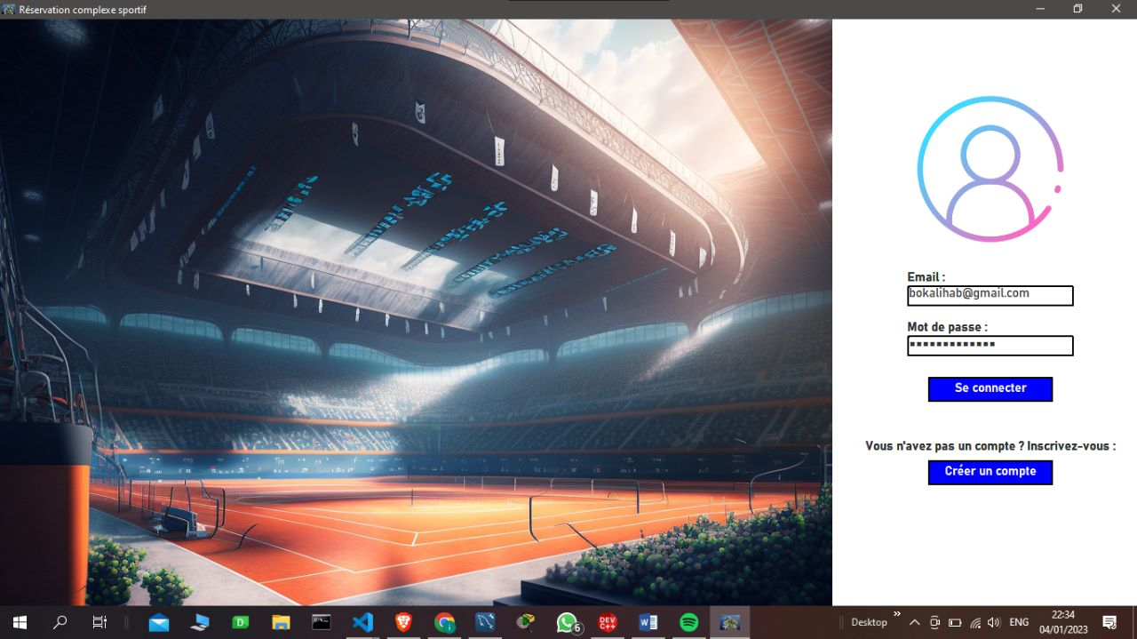

Before inserting the data in the authentication fields, the "log in" button is disabled.

* Case where the account is created :
* Case where the inserted data are wrong:

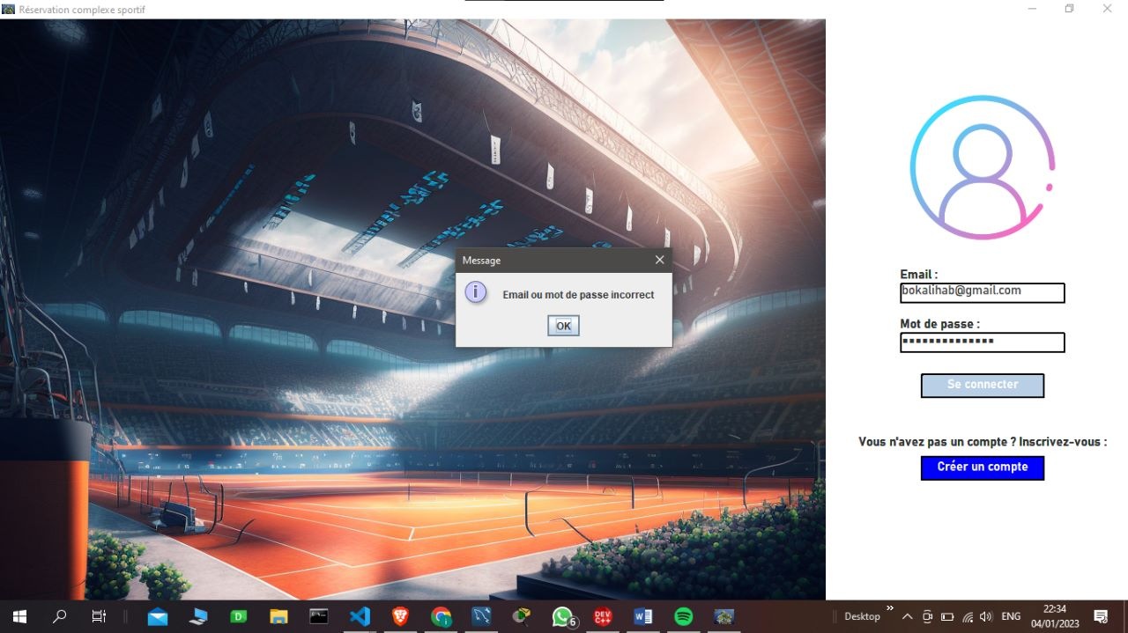

An error message is displayed, indicating that the information inserted is not in the system database

* Case where the client is connecting for the first time: 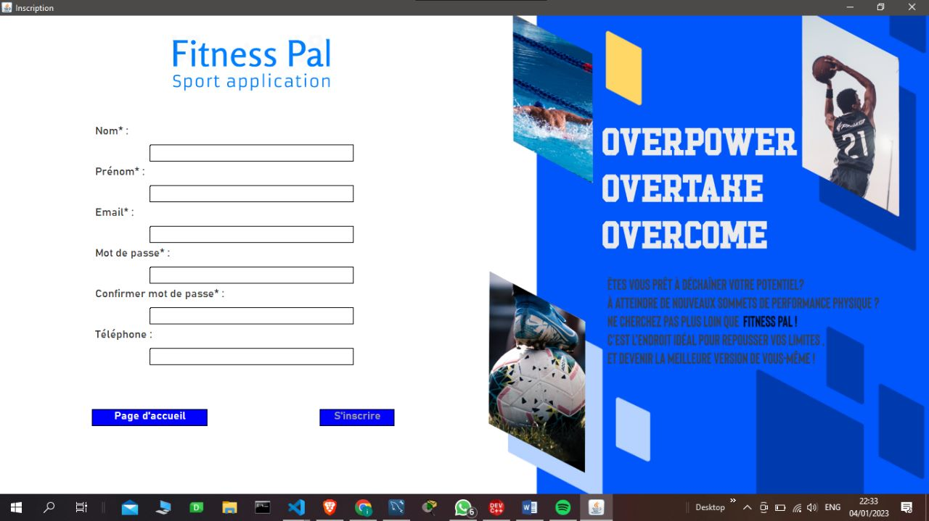

A new tab appears for new customers where they are asked to enter their personal information, the starred boxes are mandatory for the creation of the account.

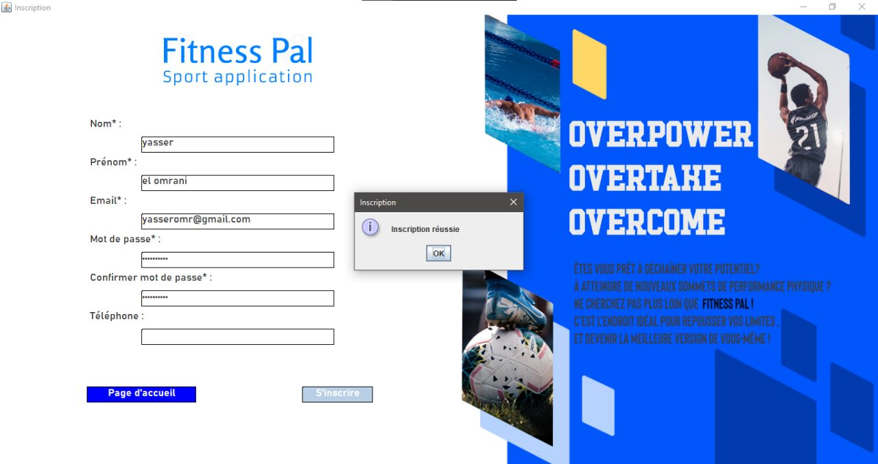

After inserting the information, the data is transferred to the database and a new message is displayed indicating a successful registration.



* **Home page**

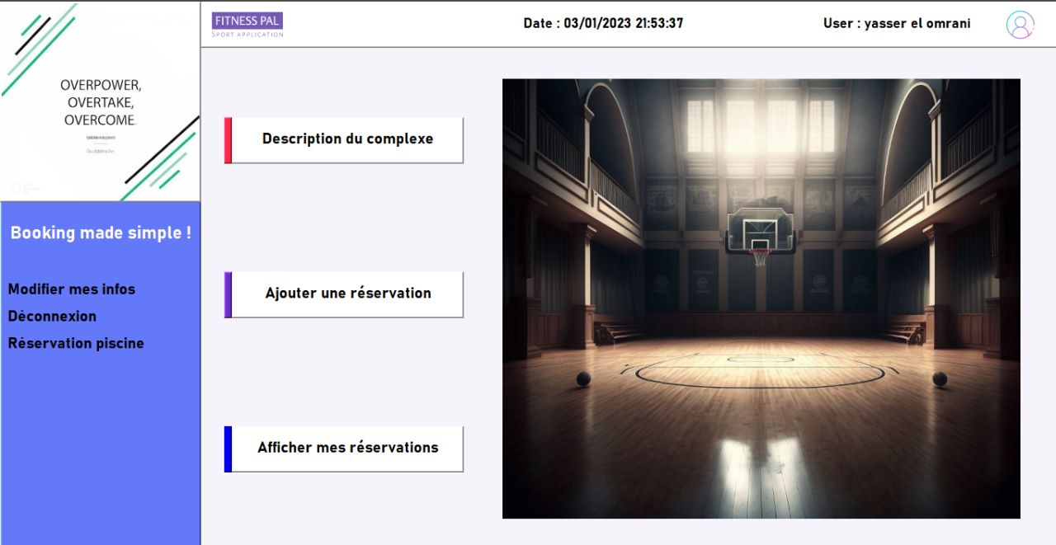

The home page is displayed after authentication, it presents several services to customers:

* 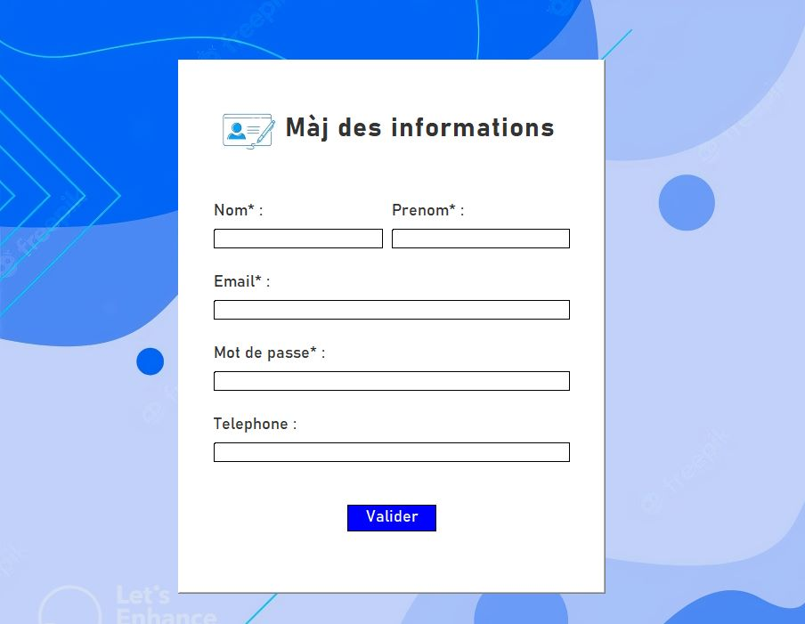**Modification of personal information:**

In this tab, the customer has access to modify his personal information that will be transferred to the database; the name and surname are displayed instantly after modification in the user icon

C:\Users\T470s\Pictures\75fa76c9-a557-4177-b2bf-c27a9e5cd09d.jfif

* **Complex Description:**

Once in the home page, the customer can learn about the complex by clicking on the "complex description" button.

* **Add a reservation :**

This button allows the customer to enter the details of his reservation ticket, just follow the steps indicated.

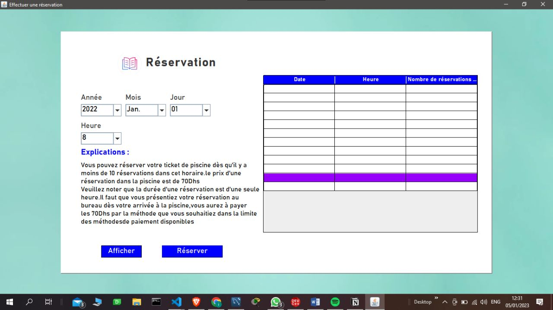

The tab that appears has two options, the first displays all the reservations made and the second allows you to add a reservation to the database.

* **Show my reservations :**

The customer can consult the reservations made by clicking on the button: "display my reservations".

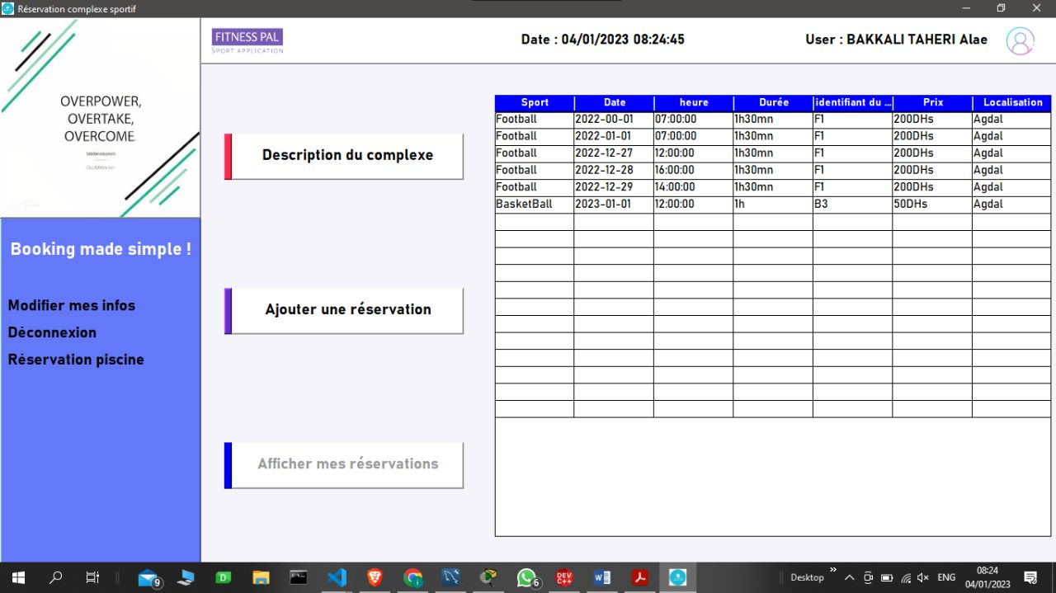

* Top panel :

C:\Users\T470s\Pictures\b4bd83fe-1d89-441a-9989-0b6c7bb289ab.jfif

The top panel contains 2 features:

* The first one displays the time and date in real time:

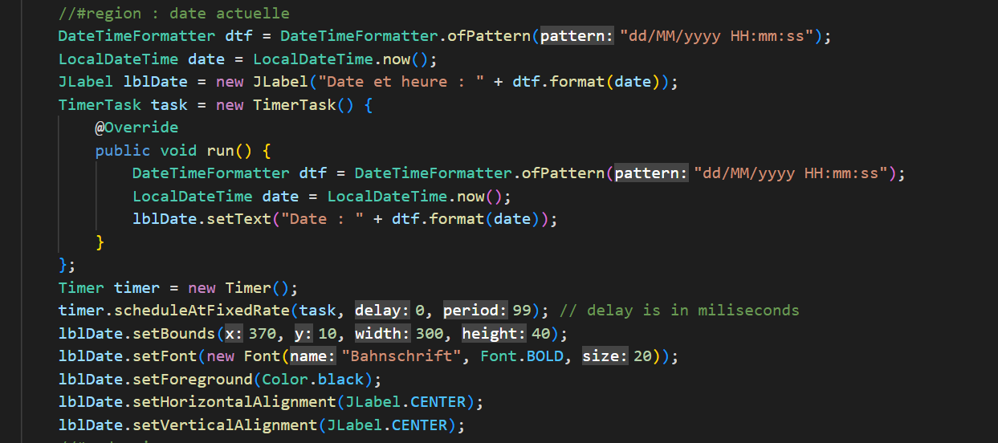

To be able to display the current date, we have created a Timer function which is called every millisecond to display the date in real time.

* The second one is the user icon where his full name is displayed. After authentication, the user's ID is retrieved and the user's full name is searched in the database to display it in the panel.

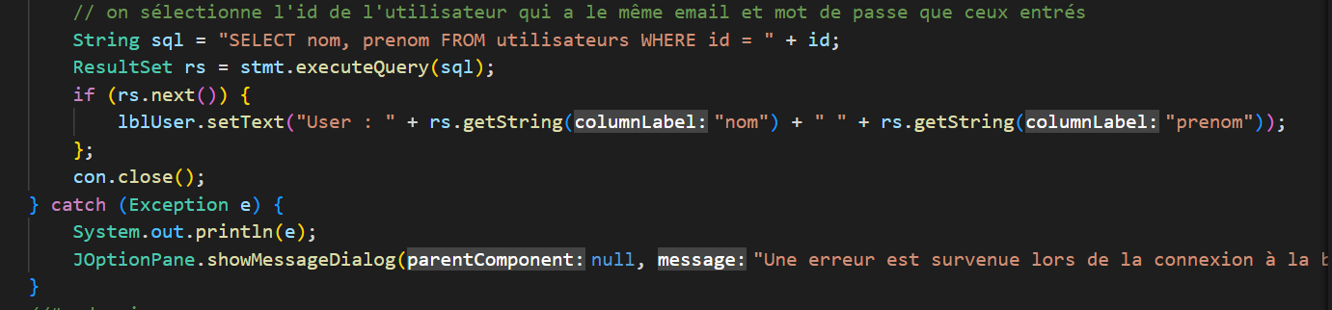

**MySQL for data storage**

To manage our databases we have used the MYSQL DBMS, in which we have created 4 tables that manage the reservations of the sports complex.

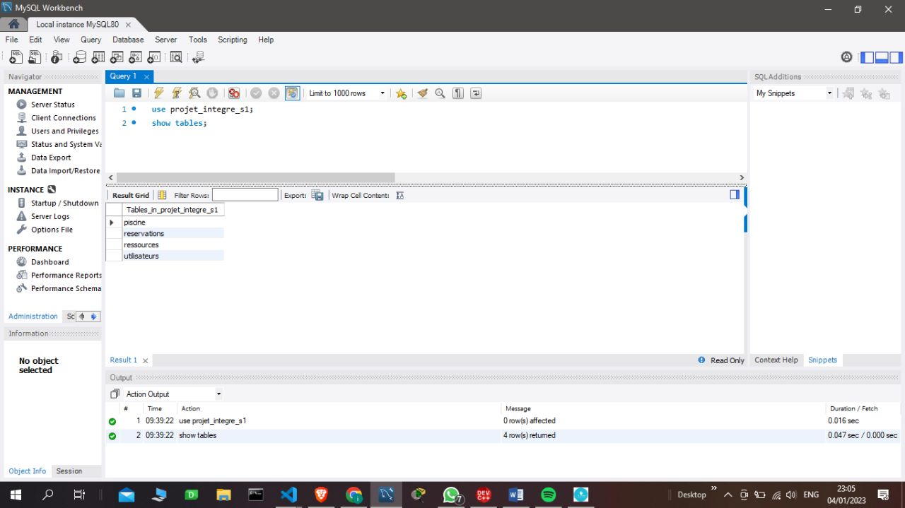

* **Pool table:**

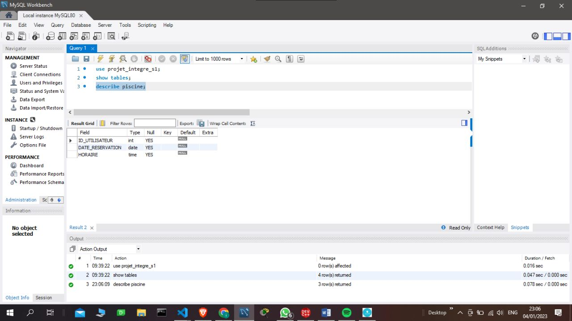

To make a reservation for the pool the system will need the login, as well as the time and date of the reservation.

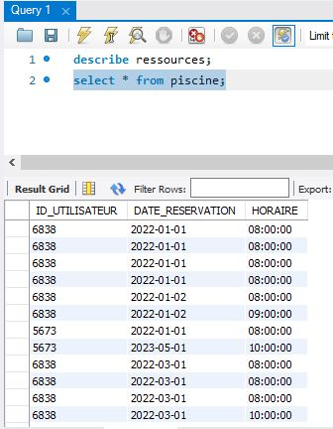

Here you can see the current pool reservations.

* **Table reservations:**

The reservations table contains all the reservations made for the various resources of the sports complex.

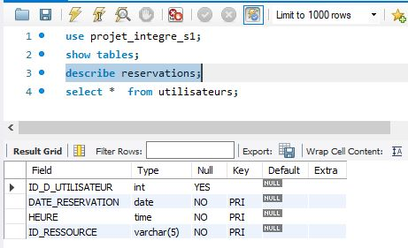

Real-time reservations are as follows: 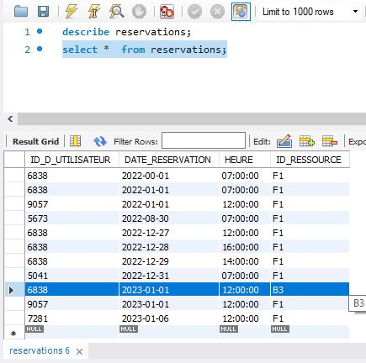

* **Resource table:**

The resources available in the complex are described by the resources table :

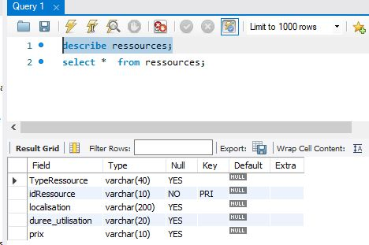

The resources of the sports complex are as follows:

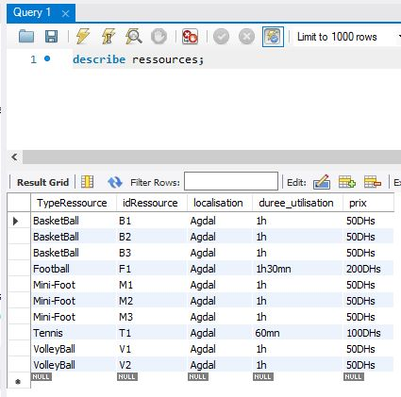

* **User table :**

Each user is identified by the information he/she inserted when creating his/her account, in addition to his/her identifier which is arbitrarily associated to him/her and is unique.

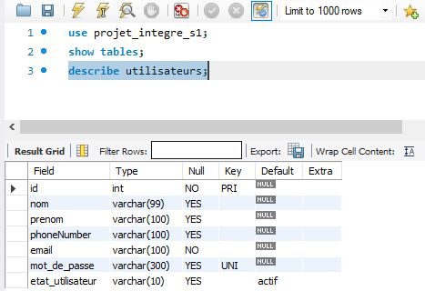

The users who have an account on the interface are :

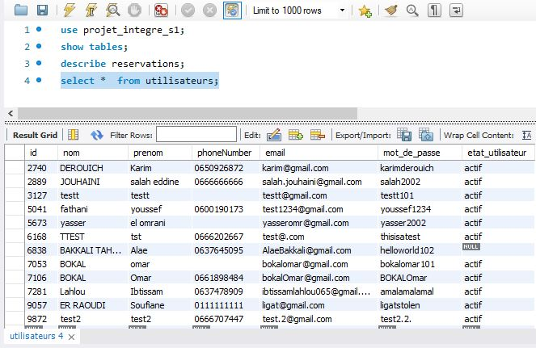

**The C language for the administrator interface**

Thanks to the C language, an interface has been created that allows the administrator of the sports complex to insert the information related to the reservations and to manage them.

* ***Login***

First of all, the administrator must identify himself:

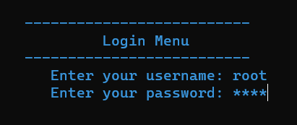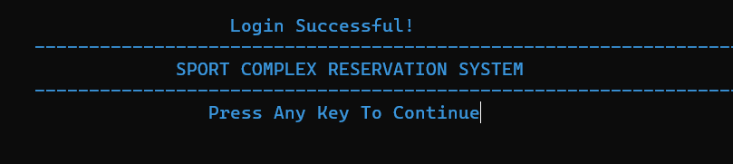

A menu is then offered to him, in which he can choose the operation he wants to perform.

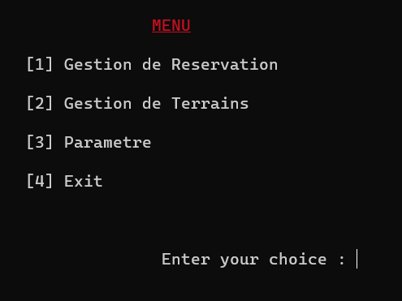

* ***Enter a new reservation***

1. **Case of sports fields**

Now, let's suppose that the administrator wants to make a reservation of a Basketball court, in the name of *Rania Oulhaj*, set on the date of *05/01/2023* from *7pm* to *8pm*.

The steps he must follow are the following:

1. **Addition of a lot:**

Before you can reserve a lot, you must first add it to the list of available lots.

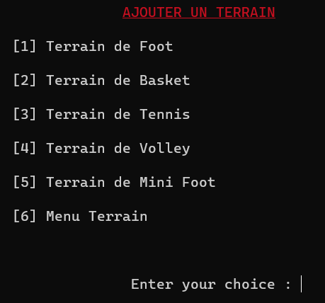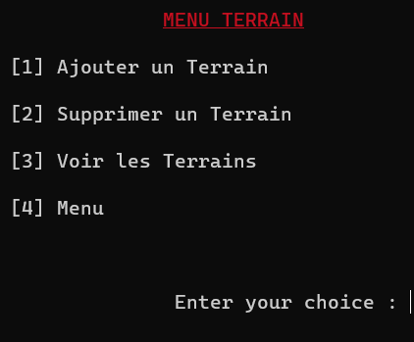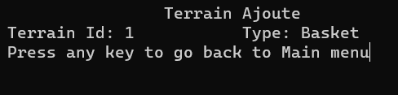

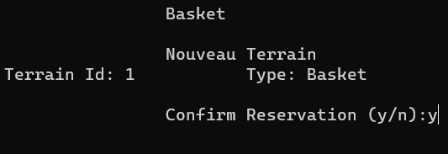

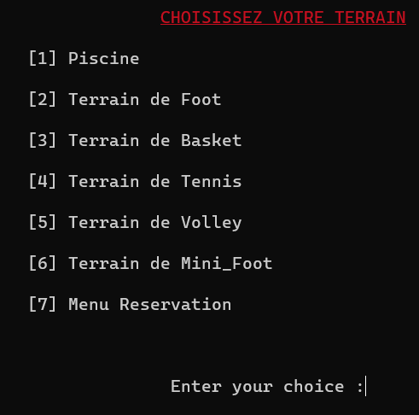

1. **New reservation:**

Once the land has been added to the inventory, the administrator can proceed to the reservation stage.

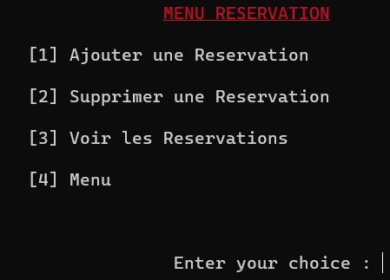



The administrator enters the reservation information, including the full name, the day chosen and the identifier of the available lot.

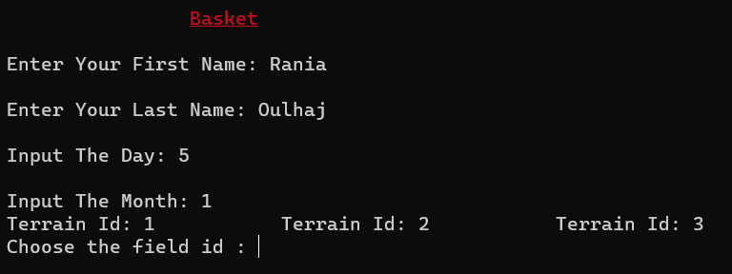

For the choice of the slot, the administrator must respect the proposed format. It is also important that the duration of the session is consistent with the opening and closing times.

As shown below, since a Basketball session lasts 1 hour, when the administrator chooses as start time: 8:30 pm, an error message appears. This is due to the fact that the complex closes at 9pm.

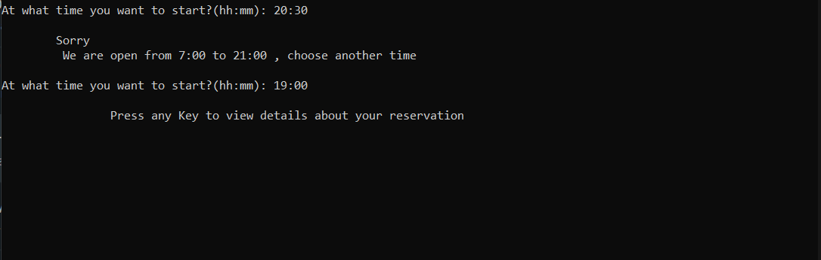

If another user chooses a slot that has already been reserved, then they will be asked to either change the Id of the field or choose another slot.

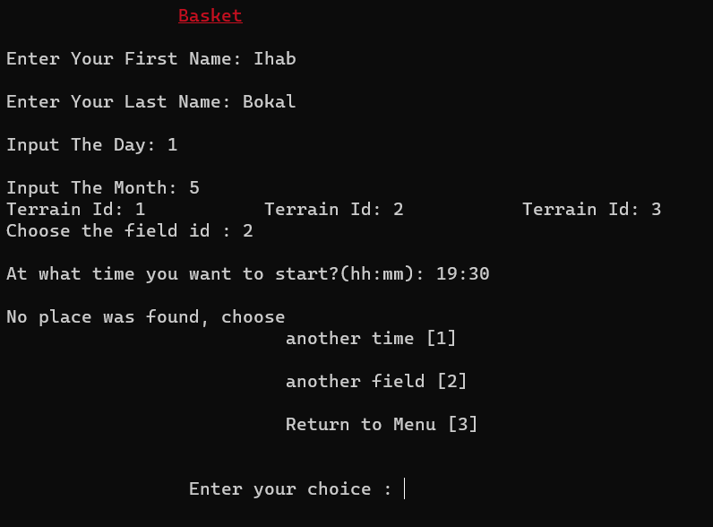

Once all the information has been entered and validated, the administrator only has to confirm his choices. A ticket is finally displayed on the screen.

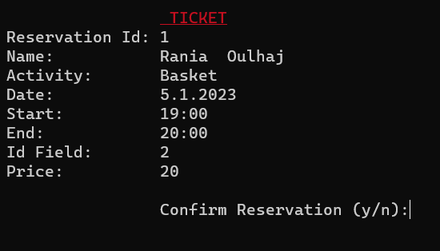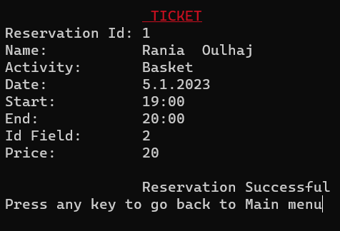

1. **Case of the swimming pool**

The pool reservation is slightly different from the land reservations. In fact, we only have one pool, unlike the other courts, which are numerous. That's why we have set the maximum capacity at 10 people for each slot.

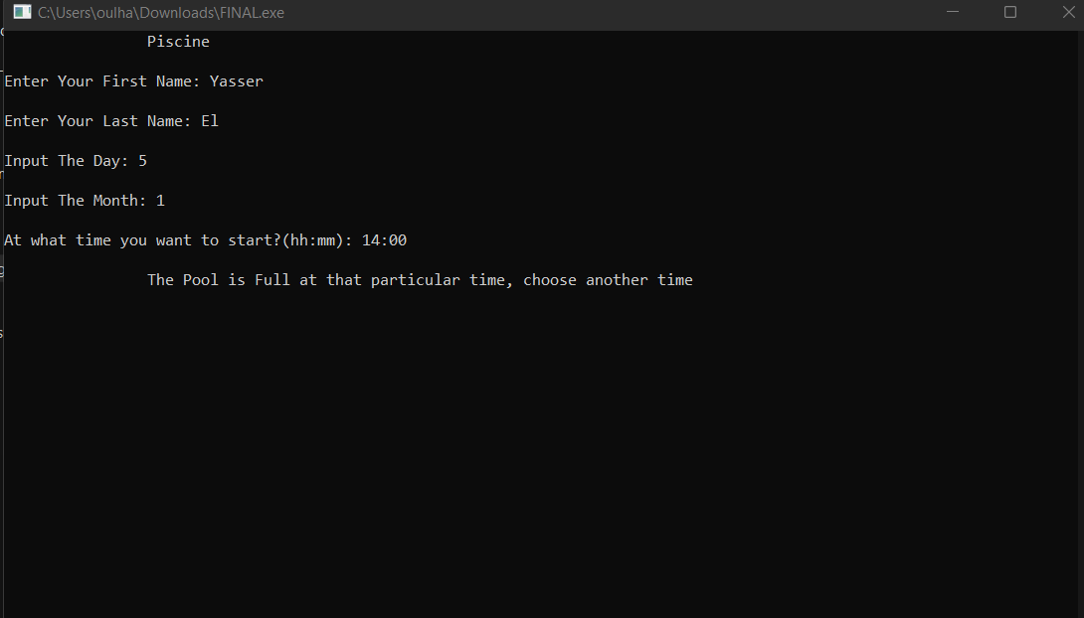

* ***Delete a reservation***

Let's suppose that the administrator wants to delete the reservation he has just made. He will only have to go back to the menu and choose the option "delete a reservation" in the "reservation management" menu.

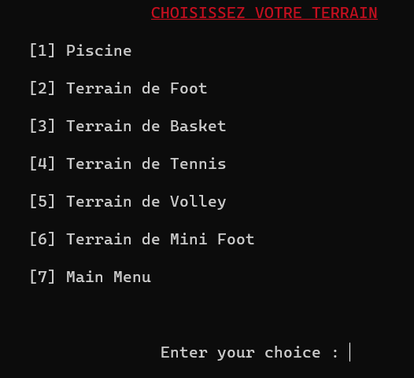

The administrator enters the ID number of the reservation, here id = 1.

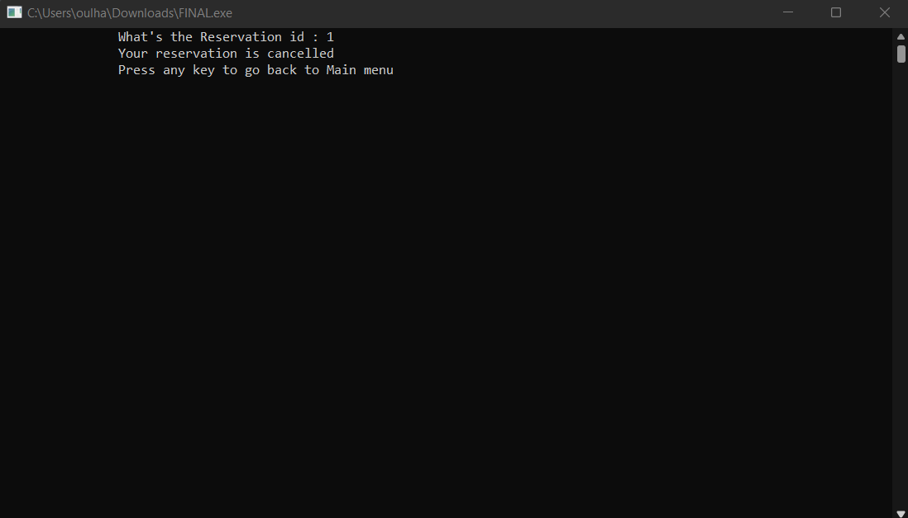

* ***Show reservations***

To display all the reservations entered, the administrator has the choice of displaying them by activity or by reservation date.

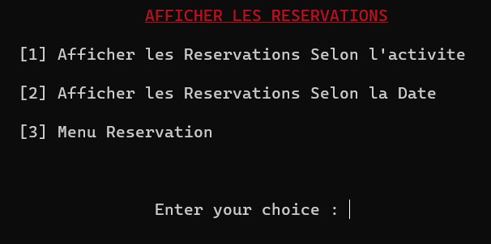

* ***Delete land***

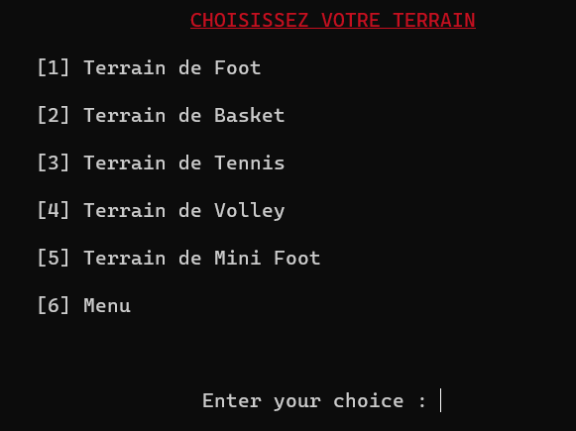

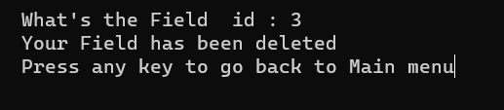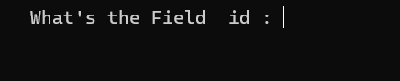

* ***Show lots***

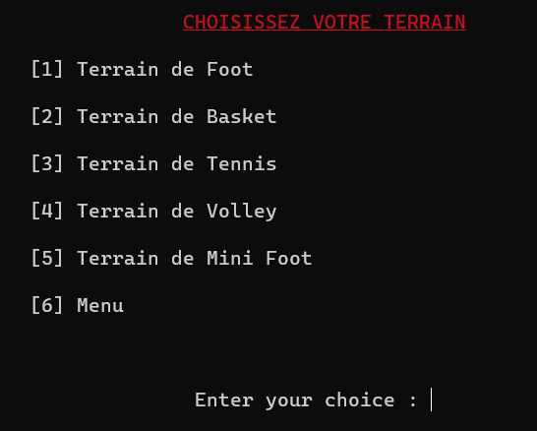

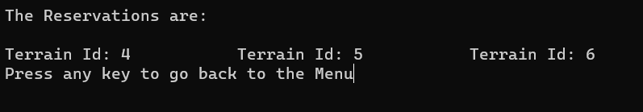

* ***Changes***

Another option available to the administrator is the modification of rates, opening and closing times, and rental periods of the grounds. All this can be accessed from the menu settings.

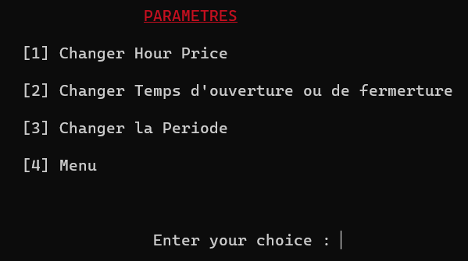

1. **Change the opening and closing time:**

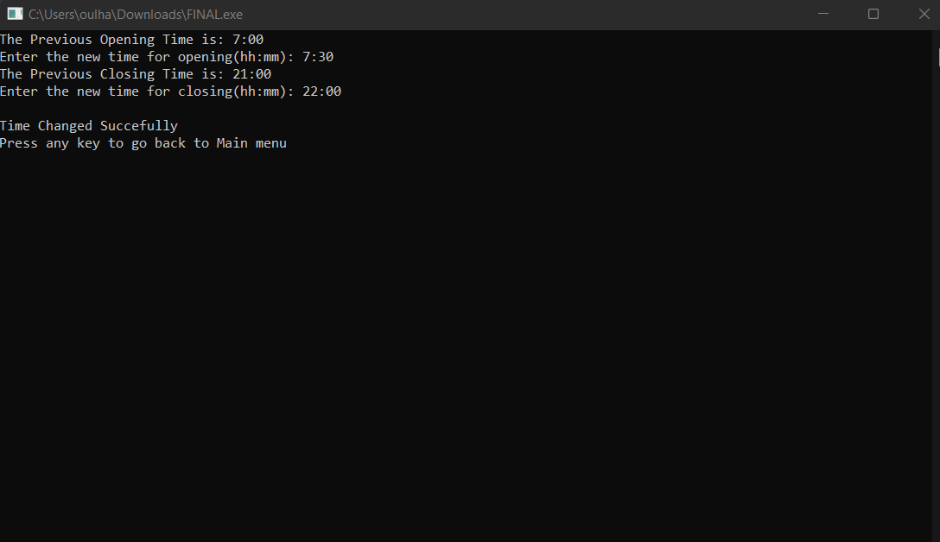

1. **Modify the period of a session according to the type of terrain:**

Here for example, the administrator wants to change the period of the soccer fields.

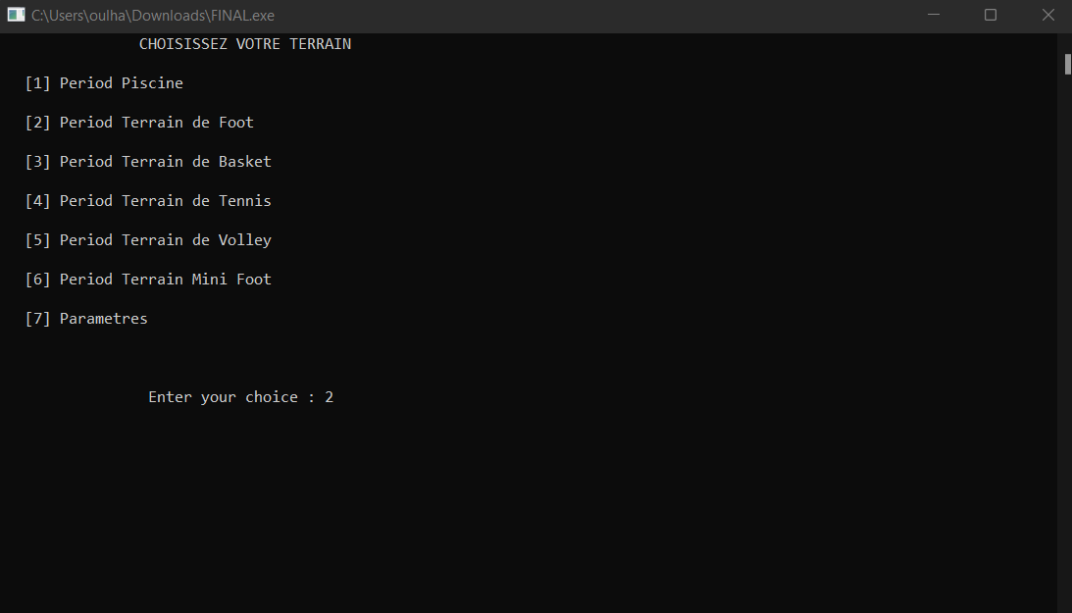

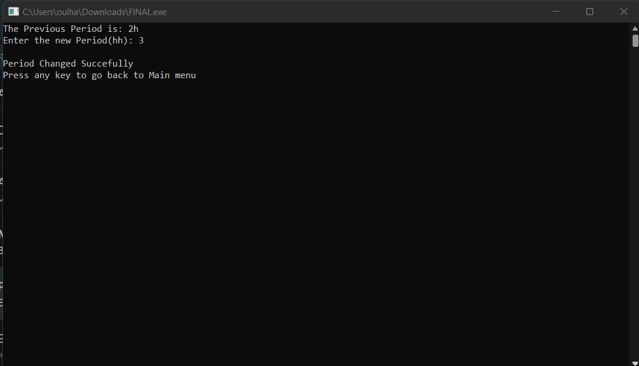

1. **Modify the rates according to the type of land:**

This is the rate for reserving a pool.

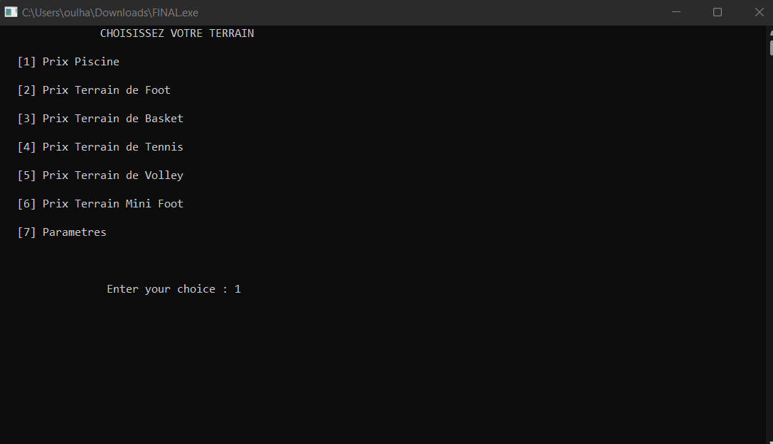

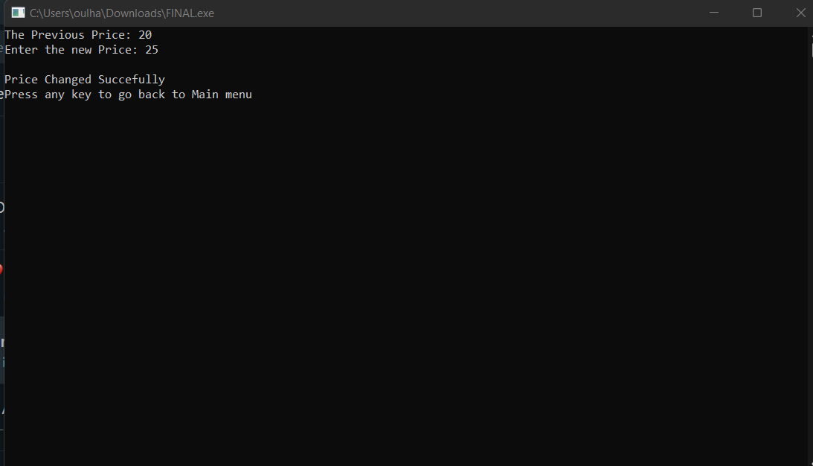

* ***Data storage***

During all these operations, the data entered is automatically stored in specific txt files.

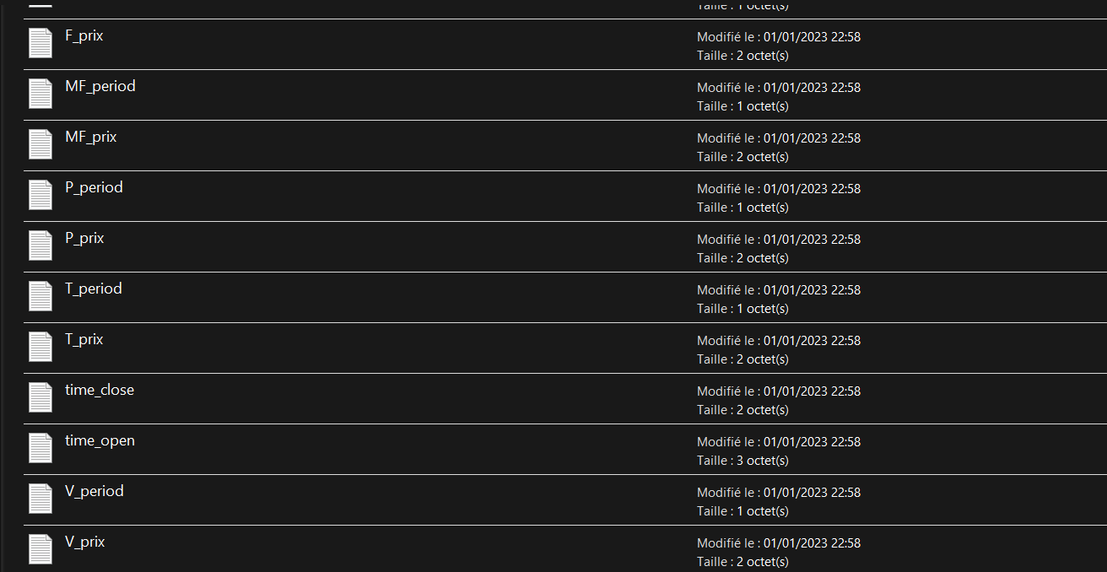

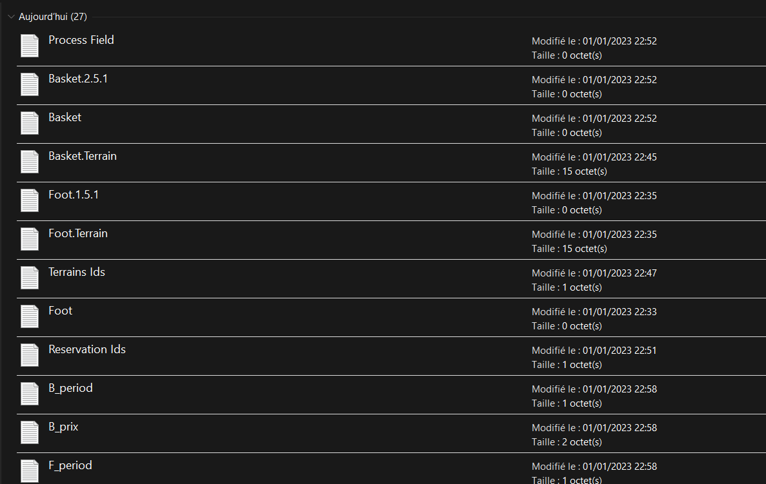

1. **Conclusion**

This project offered us an opportunity to develop our skills and knowledge in a multitude of subjects. Such as the Java language, object-oriented programming and the use of the MySQL database management system. The ability to work in groups and manage tasks was the most important lesson we learned in this project.

As for the modifications that we can make to our Fitness Pal application, as mentioned above, we can mention some of them so that it can be fully functional. We will have to use an API to have a shared DB between the user interface and the administrator interface. Our application will not be finished at this stage, it can be used publicly as long as the implementation of some options is done successfully.